INSERT INTO dish

VALUES

(1, "Sandwich", "Veg Sandwich", 30),

(2, "Sandwich", "Cheese Sandwich", 50),

(3, "Sandwich", "Grilled Sandwich", 90),

(4, "Burger", "Veg Burger", 40),

(5, "Burger", "Cheese Burger", 45),

(6, "Burger", "Chicken Burger", 60),

(7, "Pizza", "Cheese Pizza", 75),

(8, "Pizza", "Veg Loaded Pizza", 90),

(9, "Pizza", "Non-Veg Loaded Pizza", 110);

**Demonstration of Joins which includes only two table.**

Inner Join:

SELECT * FROM orders

INNER JOIN customer

ON orders.customer_id=customer.customer_id;

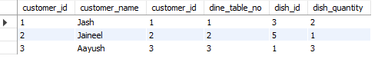

Left Join:

SELECT * FROM customer

LEFT JOIN orders

ON customer.customer_id=orders.customer_id;

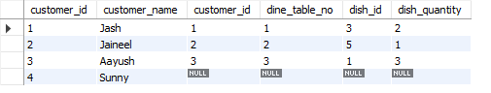

**Problem statements for Inner Joins including more than two tables.**

Q. Join orders, customer and dish tables using inner join to retrieve customer name, table number, dish name, dish quantity.

Ans.

SELECT customer_name, dine_table_no, dish_name, dish_quantity

FROM orders

INNER JOIN (customer, dish)

ON (orders.customer_id=customer.customer_id AND orders.dish_id=dish.dish_id);

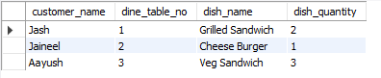

Q. Join tables using inner join to determine which customer is sitting on which table and which staff is incharge of that table.

Ans.

SELECT customer.customer_name, orders.dine_table_no, dine_table.staff_name

FROM orders

INNER JOIN (customer, dine_table)

ON (orders.customer_id=customer.customer_id AND orders.dine_table_no=dine_table.dine_table_no);

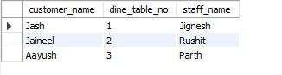

**Problem statements to demonstrate left join on more than two tables:**

**Q. Retrieve all customers, their orders (if any), the corresponding dish details, and the staff assigned to the dine table. If any detail is missing (like no order or no staff assigned), show NULL.**

Ans.

SELECT customer.customer_name, dish.dish_name, orders.dish_quantity, orders.dine_table_no, dine_table.staff_name

FROM (customer)

LEFT JOIN (orders, dish, dine_table)

ON (orders.customer_id=customer.customer_id AND orders.dish_id=dish.dish_id AND orders.dine_table_no=dine_table.dine_table_no);

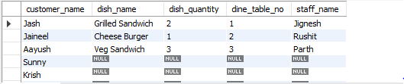

**Q. List all dishes with the total quantity ordered and the customer who placed the order. If a dish hasn't been ordered, show NULL for customer details.**

SELECT dish.dish_name, orders.dish_quantity, customer.customer_name

FROM dish

LEFT JOIN (orders, customer)

ON (orders.customer_id=customer.customer_id AND orders.dish_id=dish.dish_id);

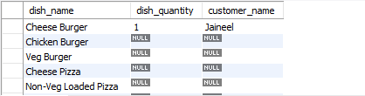

**Problem statements to demonstrate right join on more than two tables:**

**Q. List all staff, their dine tables, and the orders placed. If no orders exist, show NULL for the order details**.

Ans.

SELECT staff.staff_name, dine_table.dine_table_no, orders.dish_id, orders.dish_quantity

FROM (dine_table, orders)

RIGHT JOIN staff

ON (staff.staff_id=dine_table.staff_id AND dine_table.dine_table_no=orders.dine_table_no);

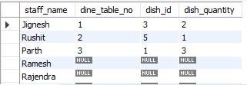

**Q. List all dishes, including those that have not been ordered, along with any existing order and customer information.**

SELECT dish.dish_category, dish.dish_name, orders.dine_table_no, orders.dish_quantity, customer.customer_name

FROM (orders, customer)

RIGHT JOIN dish

ON (dish.dish_id=orders.dish_id AND orders.customer_id=customer.customer_id);

